A Simple Algorithm for Detecting Circular Permutations in Proteins

S. Uliel,A. dliess,A. Amir and R. Unger

BIOINFORMATICS Vol. 15 no. 11 p930-936, 1999

Abstract
A possible formal description of question is: given two sequences, find a circular permutation of one of them under which the edit distance between the proteins is minimal.
1. Introduction
A circular permutation (CP) of a sequence is a string operation in which a suffix of the sequence is “cut and pasted” to become a prefix of the sequence.
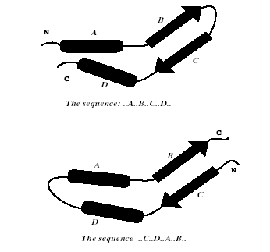
2. Method
It is a variation of the edit distance algorithm in which one sequence is compared to a duplication of the other sequence.
Basing on classical edit algorithm, we added two modifications.
The first is initialization of the first row of the edit distance with zeros, instead of the usual initialization as 0,1,2…N.
The second modification that we made is to look for the value of the best alignment amongst all of the entries in the bottom row of the matrix.

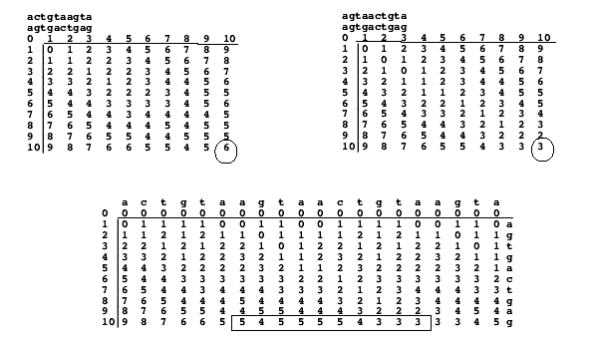

Created by: Chia-Chung Wang
Date: May 30, 2003

